
Summer 2014 Chapter of the Gran Sport Club of America; 625 Pine Point Circle; Valdosta, GA 31602 912-244-0577
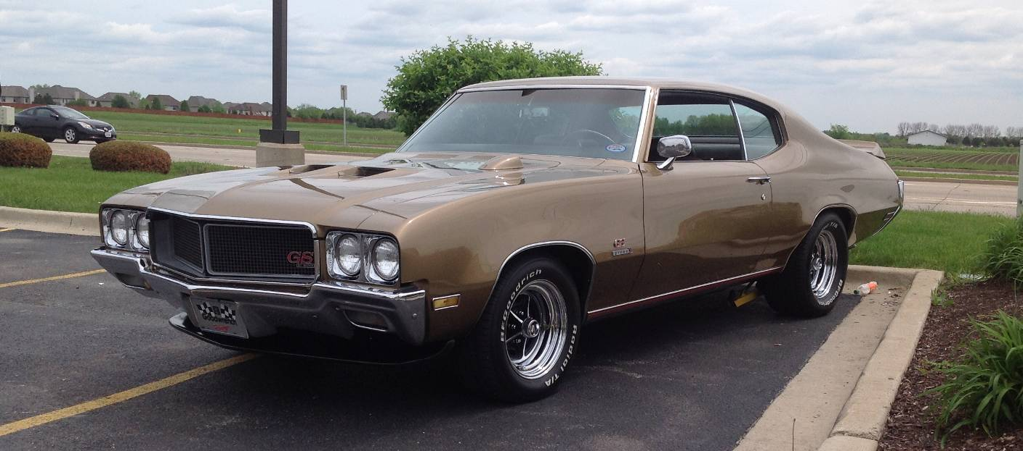
Dave Formato’s1970 Buick GS Stage 1

When Dave’s brother turned 16 he purchased a 1954 Buick Century. Dave was obviously impressed with this car at 8 years of age, so would hot wire the car and go on joy rides. Finally on one of the joy rides was caught by the Riverside police ending his young joy riding carear.
When Dave finally turned 16 he purchased a 1953 Buick which was the first year for the V8 power. At 17 Dave went in the Service. Upon completion of his duty in 1969, Dave purchased a 1958 Standard Super two door hardtop, burgundy in color with a white top. He thoroughly enjoyed this car for three years, when the traded for Corvette.
With his 1986 Corvette he went against a Grand National hauling four people in three runs including two dead start and one rolling start, loosing all three. That very day he returned to Crossroads Chevrolet and
Buick, trading in the Corvette for an 1987 Grand National. Dave thoroughly enjoyed the Grand National until 1996 when he purchased a Grand Sport Corvette.
About 26 years ago Dave purchased the cover car a 1970 Harvest Gold hardtop GS Stage 1 from the owner who lived on the Illinois / Wisconsin border who was a Mercedes Bend engineer. This car has been painted by Countryside Customs and the engine was recently completed by Jim Puracchio in Kentucky. It is a 455 stroked to 492 cu. in which produces over 600 hp on pump gas with a little octane boost. The car is outfitted with TA Stage II aluminum heads with roller rockers, TA Headers, a 750 cfm Quick Fuel carburetor, Kenny Bell Wildcat intake, Stef’s oil Pan (64 thousands between rods and pan clearance) The transmission is a TH400 with a 3000 rpm stall torque convertor. Continued on page 3

Opinions expressed in this publication are not necessarily those of the GS Club of America, the Chicagoland Chapter of the GSCA, or any of the officers of these automobile enthusiast clubs.
Chapter Volunteers |  |  |  | Member’s Change of Address  Chicagoland members who move are requested to notify our membership chairman before the next newsletter mailing. We do not want you to miss a single edition of your newsletter. Please notify us of e-mail address changes as soon as you change providers.  Membership Renewal  Please check the label on your newsletter. If your membership is up in January, June will be your last newsletter. Obtain an application from the website or past issue, and mail to 4010 Raymond Ave; Brookfield, Il 60513, along with a check for $20 made out to “CCGSCA.” Please, don’t let your membership lapse, for too long.  Volunteers for the Chapter  Contact Bob Nunes if you are interested in helping our Chapter continue exchange ideas, gathering local car show and cruise night information or plan activities for our members. Fresh ideas are needed to keep the Club exciting. Distributing the work among many volunteers makes it easy for all. The tasks do not take much of your time, and you will always have plenty of help, while hopefully having fun.  Upcoming Events  Jul 20 – Brookfield Car Show – just off the circle  Jul 25 - Franklin Park Car Show  Jul 26 – Sycamore Cruise Night  Jul 27 - CCGSCA Race #4 – Great Lakes Dragway  Jul 27 – Jimmy’s Transmission Open House/Car Show  Jul 27 – Sycamore Car Show  Jul 27 – Rizza Buick Show – Tinley Park, IL  Aug 1 & 2 - BPG Buick Horsepower Nationals – Hebron, OH  Aug 15-17 – MidWest Buick Challenge – Osceola Dragway  Aug 16 – BCA Woody Car Show – Naperville, IL  Sep 6 & 7 – BOP Shootout - Byron Dragway  Sep 7 - CCGSCA Race #5 - Great Lakes Dragway  Sep 27 - CCGSCA Race #6 “The Finals”, Byron Dragway  Sept 19 & 20 - East Coast Regional’s – Cecil County Dragway  Oct 11 – BOP Race Cordova Dragway (12th rain date)  Oct 15-18 - GS Nationals – Bowling Green, OH
Director ~ | Loyd Bonecutter | 708-485-8477
 | loydb@chicagolandbuick.org
Co-Director / ~ | Steve Russo | 815-795-4737
Gran Sport | s.russo@mchsi.com.
Co-Director / ~ | Mark Holda | 630-747-7652
Turbo Regal | M.Holda@comcast.net
Activities ~ | Paul Brelie | 224-484-8057
 | ELATED3@aol.com
Race Chairman | Joe Garcia
 | jrg3517@comcast.net
Treasurer ~ | Bill Grupp
 | jackbot@yahoo.com
Secretary ~ | Barb Holda
 | Metaz_56@comcast.net
Membership ~ | Loyd Bonecutter | 708-485-8477
 | loydb@chicagolandbuick.org
Graphic Artist ~ | Paul Vilser paulvilser@sbcglobal.netet
 | Beth Andrews draena710@gmail.com
Publisher ~ | Loyd Bonecutter | 708-485-8477
 | loydb@chicagolandbuick.org
Advertising ~ | Beth Andrews | 847-845-7342
 | draena710@gmail.com
4th of July Show | Bill Grupp
 | jackbot@yahoo.com
Midwest Challenge | Loyd Bonecutter
 | loydb@chicagolandbuick.org
Cruise Chairman | Chris Gatch | 312-485-2983
 | cgatch@comcast.net
Volunteers ~ | Bob Nunes | 630-310-6662
 | Rich George | 630-551-3120
Membership Policy & Dues
The Chicagoland Chapter of the Buick GSCA is open to all Buick enthusiasts and owners of Buick powered cars. Membership is $20 per year, and includes a quarterly newsletter and much more. Apply online at the chapter web site or send dues with check made out to CCGSCA with membership form to:
Membership Chairman
Chicagoland Chapter GSCA
4010 Raymond Ave
Brookfield, IL 60513-1846

Chapter Web Page
http://www.chicagolandbuick.org

Continued from Page 1 This car has been quite a surprise to Dave’s friend with the 450hp 454 LS Chevelle from which the Buick will definitely pull away.
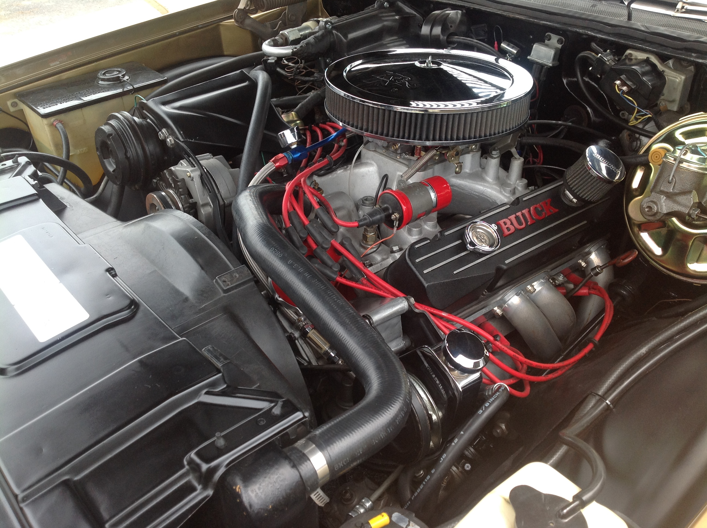
A year later Dave acquired the documented 1971 GS Stage 1 Cortez Gold convertible from Judd Hurst who was musician Alex Hurst’s son. He was there when the car came in on a transport to Volo, and offered $9,000 on the spot, which was accepted. Unfortunately this car was a little rougher than he realized needing a trunk floor and interior floor and major repair the area around the windshield. After being restored by this car has received many awards. Currently an engine is being built for this car.
Now that the weather has broke this car may be seen on most Saturday evenings at Dukes on south Harlem Avenue, Chicago, IL
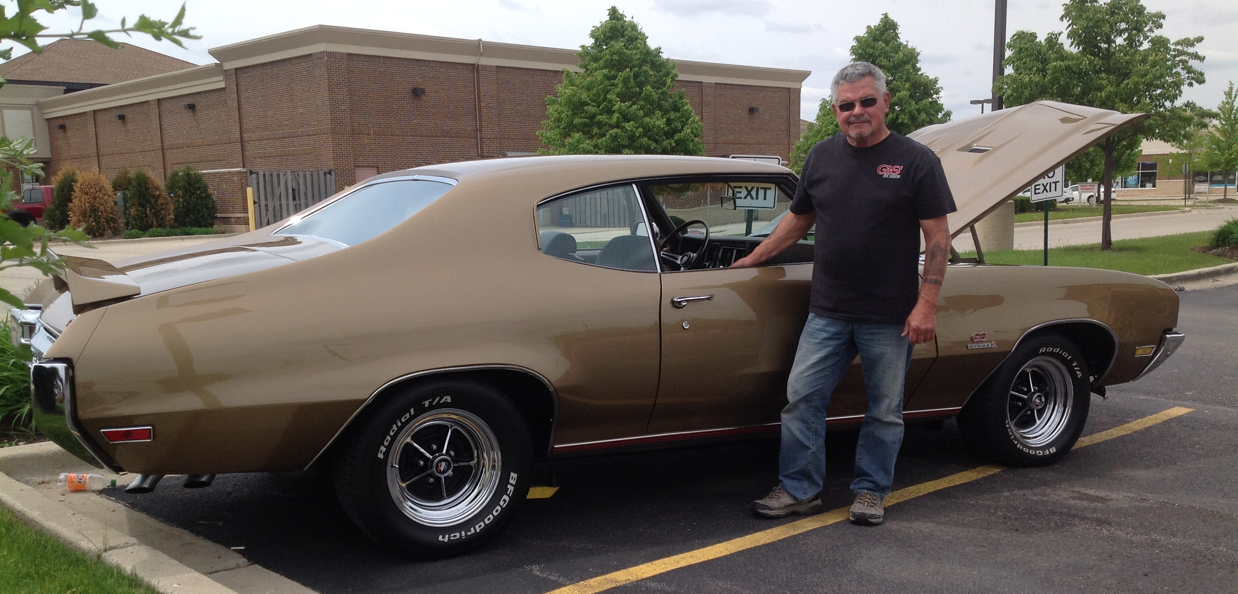
Editor: Thanks Dave for your help with this article. This is really appreciated.

Please contact Bob Nunes if interested in helping the Chapter. New ideas and ways of doing things are welcome.

Director’s Garage Loyd Bonecutter
I’m running a month and a half late this issue and I apologize. Having a relatively chilly spring brought sudden nicer weather, and I among many were not ready for the season to begin. Here it is coming up on the July 4th weekend and am finding myself in the middle of the car crazed season.
Presad and Benny put together a great event for Turbo Regal owners at the Holiday Inn in Itasca, IL on June 6,7 &8, 2014. It drew over the course of three days about 130 Turbo Regals, showing there are lots of folks who remain passionate about these cars. There were a lot of folks who came a long distance as there were lots of great venders, technical sessions and great sharing of information.
There are an incredible amount of cruise nights available in our area, so finding a place to use you hobby car in this area is very easy, and has taken me from keeping up with Chapter duties. Maybe it is time to slow down and keep others more involved. For the first time in around 28 years took a Florida vacation with my immediate Bonecutter family instead of a car related vacation.
This spring started using the Grand National after allowing it to sit for a few years. Yes one or two trips and at least one oil change a year is all it saw. Needless to say it protested with one no start after a Wednesday night cruise night. In diagnosing the problem it was discovered to be self inflicted in the curse of my changing fuel injectors several years ago. One of the injector power wires was pinched under the coil bracket, and eventually wore through thus shorting blowing the 20 ampere injector and fuel pump circuit breaker. This led to discovering a very slight leak under one of the rubber insulating strips on the gasoline tank bracket. Poor old gasoline tank only lasted 28 years, with this area holding salt and dirt leading to the leak. I decided to get a new hanger for the electric fuel pump as the fuel gage as the fuel level has not read correctly for years now.
Changing the fuel tank lead to breaking a chunk of plastic off the rear bumper fillers, so replacements had to be purchased, painted and installed. Thanks to Dave Anderson at Tamraz for his help in securing those items. Lastly the front brakes were pulsating when coming to a stop.
A few discoveries were made when working with Brian Hendrickson on the brakes. Brake jobs were straight forward, but I have not been bending the tabs on the replacement brake pads to secure tightly to the calipers. Since the sleeves were not sliding easily over the bushings (interior rubber “O” rings) and the caliper was not greased where it slides over the caliper bracket were not lubricated with the brakes after a few blocks of use were extremely hot. After being serviced they worked perfectly and were warm, not hot upon arrival at the garage on the return trip.
Lessoned learned is to review specific maintenance procedures such as brake jobs, before attempting. Having all the correct tools on hand is also very helpful.
More useful information came from Glen Boiko of Highway Starrs at the GN/TType Central Gathering in Itasca. In particular were the markings on the serpentine belt tensioner and the correct length of belt for 1986 and 87 Turbo Regals. I did not realize the belt tensioner provides a window with markings to show the correct length serpentine belt. Unfortunately most parts houses sells a 1640 mm (64.5 inches) long belt when the correct length is 1616 mm (63.6 inches). Brian Hendrickson recommends use of the Goodyear Gaterback Serpentine belts (part number 4050635)
I have been slow on renewing members so if you check has not cleared yet please get hold of me. I keep finding renewals that get lost in the paper shuffle.
There are a lot of things left to do this summer, so hopefully will be seeing many of you at upcoming events..

Please be sure to use your CCGSCA discount at one of the Insurance Agencies advertised in this newsletter.

2014 Daily Summer Cruise Schedule
MONDAY:
Countryside Best Western - Route 66 Cruise Nights
Hoffman Estates Barrington Square
Downtown Manhattan Cruise 2nd Monday of Month
Westchester 31st and Wolf Road
Westfield Old Orchard; Skokie – West parking lot

TUESDAY:
Downtown Tinley Park - Oak Park Ave near the RR
Plainfield – West Lockport Street west of Rte 59

WEDNESDAY:
Brookfield – Sanctuary on Grand north of RR tracks
Downtown Cary – near Metra Station
Darien Q Bar & Grill – 8109 Cass Ave
Downtown Libertyville (3rd Wed of Month)
Mundelein Park On Park
Streamwood Sonic - 590 Barrington Rd
Lake Zurich Main Street Cruise Night (1st Wed)

THURSDAY:
Carol Stream - Carol’s Restaurant 515 S Schmale
Frankfort - 15 Kansas St,
Geneva - 4th and James Streets (July thru Aug.)
Mundelein (1st, 3rd & 5th Thurs. of month)
Downtown Westmont – North of RR on Cass
Schiller Park - Hubcaps on Ruby (2nd & 4th Thurs)

FRIDAY:
Downers Grove Main Street
Rolling Meadows - 2401 Kirchoff Road
Roselle Brunswick Zone

SATURDAY:
Bolingbrook Tailgators Bar
Hoffman Estates Buona Beef
Tinley Park Flea Market

SUNDAY
Bartlett Nicodinos Pizza

Please submit suggestions to add to the list!
A DAY TO REMEMBER by Bob Nunes
June 8th, 2014 at the Holiday Inn, in Itasca, Il
During the day, we had a car show called “The GN/T Type Central Get Together”.
The show was well represented by over 100 GN’s and T Type Buicks. Two months earlier. Prasad had asked me if I would talk about the Chicagoland Buick Club and its beginnings and the first time I had met Shari and Loyd Bonecutter. Prased informed me that they were going to award a lifelong achievement award by the Buick community. I said I would be happy to do it; we successfully made it without Loyd knowing.
To make it a nervous time, we were expecting Loyd to be there early, you know if an event starts at 9:00am Loyd is there at 7:00. However, Loyd had not shown up by 10:00am, people were starting to get nervous. We knew he had car trouble from the night before. I tried calling him two times, but no answer. Then we saw him enter the parking lot with his Chevy SS. We relaxed.
The show ended. We were going inside the hotel for the award presentation and tech session. Prasad came to me and said he thought Loyd may have left because they can’t find him. I went outside to look for him because I was the last one to see him. Turns out he was just getting his car to bring a part home for Scott Pitts. We got him to the room and sitting up front.
Prasad and Benny introduced me, I talked for awhile, then they awarded the plaque to Loyd, he was totally shocked, he had no idea. I hope he will bring it to some events so you all can see it, it’s really beautiful.
To end, all members of the Chicagoland Buick Club owe a lot to Shari and Loyd Bonecutter for making the club the best club I have ever been part of. I think of them as the best friends I have ever had.
Thanks Loyd and Shari for everything you have done,
Bob Nunes
The following are some things you might find interesting:

1968 | Engine | Carburetor | Description | Number GS made
Two door pillar coupe  (California GS) | 350 cid | 4 bbl | PP | 4831
Two door hardtop | 350 cid | 4 bbl | PP | 8317
Two door hardtop | 400 cid | 4 bbl | PR | 10743
Two door convertible | 400 cid | 4 bbl | PR | 2454
 |  | Transmission breakdown not given
 |  |  | Total production GS - 26345
1969 | Engine | Carburetor | Description | Number GS made
Two door pillar coupe  (California GS) | 350 cid | 4 bbl | RP | 3574
Two door hardtop | 350 cid | 4 bbl | RP | 6305
Two door hardtop | 400 cid | 4 bbl | RR | 7602
Two door hardtop | 400 cid | 4 bbl | RS | 1256
 | Stage 1 – Four Speed Manual:415 TH400 Automatic: 841
Two door convertible | 400 cid | 4 bbl | RR | 1776
Two door convertible | 400 cid | 4 bbl | RS | 212
 | Stage 1 – Four Speed Manual:77 TH400 Automatic: 135
 |  |  | Total production GS - 20725
1970 | Engine | Carburetor | Description | Number GS made
Two door hardtop | 350 cid | 4 bbl | SP | 9948
Two door hardtop | 455 cid | 4 bbl | SR | 5189
Two door hardtop (Stage 1) | 455 cid | 4 bbl | SS | 2454
Two door hardtop | 455 cid | 4 bbl | SR | 199
 | GSX – Four Speed Manual:79 TH400 Automatic: 120
Two door hardtop (Stage 1) | 455 cid | 4 bbl | SS | 479
 | GSX Stage 1 – Four Speed Manual:199 TH400 Automatic: 280
Two door convertible | 455 cid | 4 bbl | SR | 1884
 | Three Speed Manual:18 Four Speed Manual:126 TH400 Auto: 1040
Two door convertible | 455 cid | 4 bbl | SS | 232
 | Stage 1 – Four Speed Manual:67 TH400 Automatic: 165
 |  |  | Total production GS - 20727
1971 | Engine | Carburetor | Description | Number GS made
Two door hardtop | 350 cid | 4 bbl | TB | 7588
Two door hardtop | 455 cid | 4 bbl | TR | 680
Two door hardtop (Stage 1) | 455 cid | 4 bbl | TS | 2454
Two door hardtop (GSX) | 350 cid | 4 bbl | TB | 124
Two door hardtop (GSX) | 455 cid | 4 bbl | TR | 124
Two door hardtop (GSX) | 455 cid | 4 bbl | TS | 124
Two door convertible | 350 cid | 4 bbl | TB | 656
Two door convertible | 455 cid | 4 bbl | TR | 165
Two door convertible | 455 cid | 4 bbl | TS | 81
 |  |  | Total production GS - 10095
Please note your membership expiration date is listed on the address label

Joe Garcia - GSCA Racing Chairman
Remaining Race Schedule
July 27, - Great Lakes Dragway
Sept 7 - Great Lakes Dragway
Sept 28 – Byron Dragway
Points after the Third Race at
1) 132 Pete VanTholen
2) 130 Joe Garcia
2) 130 Dennis Butt
3) 129 Dan Weilland
4) 119 Steve Pitts Jr.
5) 100 Ed Wolters
6) 085 Loyd Bonecutter
7) 080 Dave Smith
8] 076 Scott Pitts
9) 072 Paul Dubois
10) 069 Rich George
11) 066 Bill Grupp
12) 065 Bob Hoffman
13) 060 Brian Henrickson
14) 041 Dana Andrews
15) 038 Perry Carlini
16) 038 Keith Egan

