SPECIALIZING IN REBUILT GM TRANSMISSIONS
Call about putting a TH 200 R4 in your Street Rod or Muscle Car to make it a real cruiser
You will be glad you did for the mileage and still run the gears for quick acceleration.
Call JIMMY @ 847-949-7507
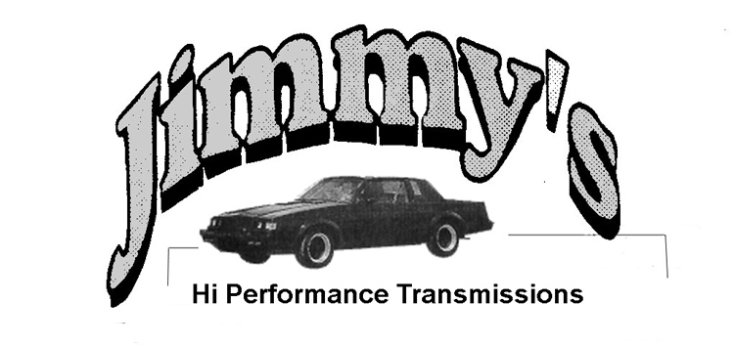

Call Jimmy about your Corvette needs as well
TRANSMISSIONS  J-200 4R S  HDS Hardened Stator  Wide Alto red lined band  Shift Kit  Transgo pump ring kit  13.00 Sec. and up  J-200 4R SS  All of above plus  10 vain rotor (pump)  New pressure regulator valve  Line pressure regulator spring  Line pressure boost valve 0.500  2nd reverse boost valve 0.300  Alto race red clutches 3rd & 4th  Competition Valve Body  Pan Spacer & 700 4R Filter  11.50 Sec. and up  J-200 4R SSR  All of above plus  Steel input shaft Forward Drum  Billet Servo 2nd Gear  Bearings in place of thrust washers  Dual Feed with new 3-2 control system  4130 Steel Band Anchor  A 0.500 booster valve  Triple 3rd pressure & clamping force | Jimmy has a complete line of hardened parts  OPTIONS:  Trans Brake  Steel input shaft  Steel Over drive carrier & ring gear  Deep Aluminum Pan  TORQUE CONVERTERS  Precision Industries  JW Performance  TRANSMISSION COOLERS  Long  TRANSMISSION FLUID  AMS Oil Synthetic  Jimmy's Hi Performance Transmissions  A Division of H.P. Performance  888 N Tower Road  Mundelein, IL 60060  Web site: http://jimmys-trans.com/ or 847-949-7507  SHIPPING AVAILABLE

FULL LINE OF AUTOMATIC TRANSMISSION PARTS NEW AND REBUILT
Getting your transmission done right the first time saves money, time and aggravation
Call Jimmy for his winter slow season specials for the rebuild you have been putting off.

